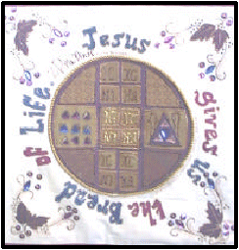

In the second panel, we used the symbol of the paten, that is used to make an imprint on top of the bread (the prosforo) given as an offering to God, during the Liturgy, who then transforms it through the Holy Spirit and gives it back to us as His Precious Body. The various parts of the paten were appliqued by Mrs Angelis, and the children took turns in decorating the paten and vine leaf border with crystal beads, sequins and by coloring in the words. Once again, each child's name has been written on to the finished product together with their class teacher’s name, Ms Dimas.

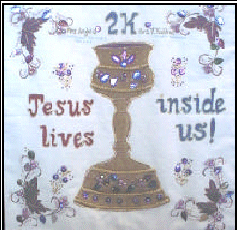

This term in Year 2, the children will be learning more about the our Church and that it is something special when they are members of the Orthodox Christian Church. They will learn that the Divine Liturgy is the most important service of our Church and that during the Liturgy they are joined with Jesus when they take Holy Communion. The theme for the Year 2 panels was inspired by the words of Jesus, who said, "I am the Bread of Life." (John 6:48) and, "He who eats this bread will live forever." (John 6:58) He is indeed the living bread which brings us life and He offers himself for our salvation. The Holy Chalice was richly decorated by the children with crystal beads, sequins and leaves after their OS teacher appliqued the image of the chalice and the vine leaf border. Each child's name is to be found woven around the curved lines of the border. We are reminded that just as many grapes pressed together make wine, so too, many people make up the family of God because we share the life of Jesus.

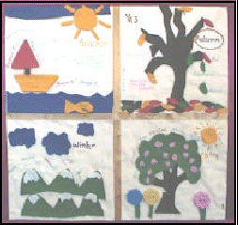

IN THE BEGINNING GOD CREATED THE WORLD AND EVERYTHING IN IT…….SUMMER, AUTUMN, WINTER and SPRING.
God loves us so much, He gave us the changes in the seasons for us to enjoy. Year 3C depicted the 4 seasons on our panel on the quilt. The children worked in groups of 4, each group having a rough sketch of what their season would look like. The children then had the task of drawing their pictures onto different coloured felt, cutting out the shapes, then sticking them onto the piece of calico fabric. Summer is the sea with the sailing boat and brightly coloured sun. Autumn is typically portrayed by the falling of autumn leaves in red, brown, green and gold, from a bare-branched tree. Winter is shown depicted using snow-peaked mountains with white fluffy clouds, and Spring, of course, is a display of brightly coloured flowers, using felt and buttons. The four seasons were divided up by a gold ribbon. Many thanks to Ms Cassimatis who kindly wrote all the children’s names on the calico fabric using her special talent of caligraphy. Great work 3C.

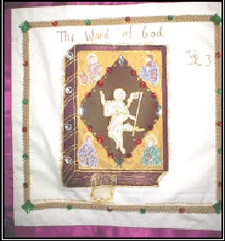

“In the beginning was the Word, and the Word was with God, and the Word was God”. JOHN 1:1
Holy Scripture is given by God not only to humanity in general, but to each individual, to me, to you, to everyone….. Every time we read the gospel to ourselves or hear it in Church we hear God conversing with us. We need to read and listen to the Holy Gospel by opening the ears to our heart. We need to let the Word of God quench our soul, just as water quenches the thirst of the driest desert. Just as man cannot live without water, he also cannot live without the Word of God, which leads us to salvation. In 3P, the Bible image was prepared by their Orthodox Studies teacher, using gold and burgundy fabric. In the centre of the image Christ is depicted (who should also be the centre of our lives). Surrounding Christ are the four Evangelists, Matthew, Mark, Luke and John (the apostles who wrote the 4 books of the New Testament).
The children took turns in decorating the Bible image and the gold braid around the Bible, using coloured rhinestones. The children’s names were written in small letters around the braid. Miss Papadopoulos, their class teacher, kindly decorated the bookmark inserted in the Bible by using sheer gold ribbon, fabric paint and small beads. The end product was a rich display of a TRULY RICH GIFT that has been given to us by God. Well done 3P.

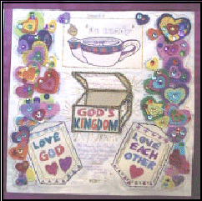

Jesus said…. ‘And you shall love the Lord God with all your heart, with all your soul, with all your mind, and with all your strength.’ This is the first commandment. "And the second, like it, is this: ‘You shall love your neighbour as yourself.’ There is no other commandment greater than these." Mark 12: 30 - 31
When we allow our heart to be free to love God and our fellow man, we discover the miraculous power of faith. In fact, the more faith we develop the greater the love God gives us, the more love we nurture the greater the seed of faith grows. The two elements
of Faith and Love cannot be separated. This cycle has no end and perfects itself through Jesus Christ, so that truly "..mountains can be moved..".
The Year 4 Orthodox Studies programme is centred on this theme and incorporates many varied stories for the Bible and other Holy sources such as the "Gerontikon", which reveal that many miracles continue even now to occur, when people put these two commandments into practice.
Mrs Giantsos’ students embraced these commandments wholeheartedly. Jesus’ message, written on calico fabric, "To be ready for God’s Kingdom by Loving God and each other", was coloured in by each of the students so happily and carefully. Each child decorated many felt hearts and then connected them altogether to show that we are all one heart in our love and faith. The sparkling jewels used on them represent the many varied and precious virtues and talents each person has been given by God. The message truly is that we must always be the light of the world, we must keep that flame lit and be ready………

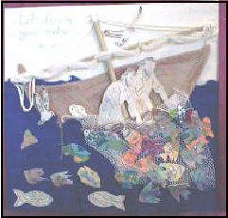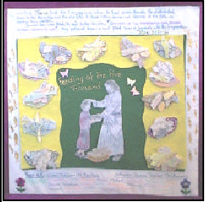

Faith manifested itself when Jesus asked Peter to "..let down your nets.." and Peter exclaimed, "I will do as you say". Miraculously, faith and love combined at that moment and behold the nets were lifted and dozens of fish hauled in, even after a fruitless night of fishing by the Apostles. Mrs. Menegatti’s class adored this story and each student gleefully decorated their own calico fish (with bright metallic colours), which was then positioned onto the white nets. The backdrop, pictures Peter and Andrew, in their boat dragging the heavy nets out of the water. The sequins used on the sea creatures really did give them a "fishy" feel………….

Mr Roubos’ class enjoyed colouring and decorating the "12 baskets of leftovers", which a part of the quilt depicting Jesus blessing that child who out of faith and love offered his food of two fish and five loaves. The synergistic effect of allowing our love and faith to be joined with God’s, does indeed produce miracles. Over five thousand people, not including women and children, were fed and there were even 12 baskets of leftovers. Green and yellow felt was used as a backdrop, with the image of Jesus blessing the child, positioned in the middle. The decorated calico baskets containing the remnants were positioned around Jesus to symbolise the circle of love and faith. The Orthodox Church continues to offer thanks for the bread we all receive, in a special service called the "The Blessing of the Five Loaves"

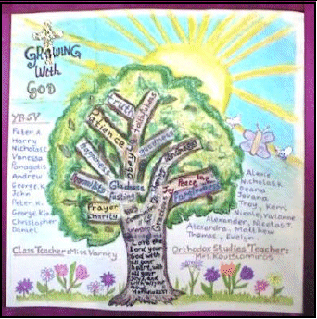

This panel depicts one of our lessons in Orthodox Studies, which taught us that we grow when we obey God’s word. In this
lesson we learnt that people grow in many ways, emotionally, intellectually, spiritually, as well as physically. People need more than food to grow. To show how people can grow spiritually, Jesus told the story [a parable] about planting a seed. [Luke 8:4 - 15]. Jesus explained that the seed in the story is God’ s word [God’s teaching] and the ground in which the seed is planted are the hearts of people. People can act in different ways when they hear the word of God, depending on the condition of their heart. Jesus said, “ the seed that fell on good grounds like those who hear God’s teaching with a good honest heart. They obey God’s teachings and patiently produce good fruit.” [Luke 8: 15]
In other words, when we obey God’s teaching, the Spirit of God helps us to produce “good fruit”. The “Spirit of God gives love, joy, peace, patience, kindness, goodness, faithfulness, gentleness, self-control.” [Galatians 5:22] These, as well as other virtues, are the “good fruits” that we produce when we allow God’s word to grow in our hearts. The tree on our panel represents “the seed” [God’s word] which has fallen on “good ground” [people with good honest hearts] and has sprouted and grown to produce the “fruits” of God’s spirit. The words that have been written on the branches portray the “good fruits”. Each student, under the supervision of their Orthodox Studies and class teachers, meticulously and enthusiastically contributed to the completion of the panels by writing, by beading, and colouring-in using fabric crayons and craft pens. The students’ and teachers’ names have also been added to each of the panels.

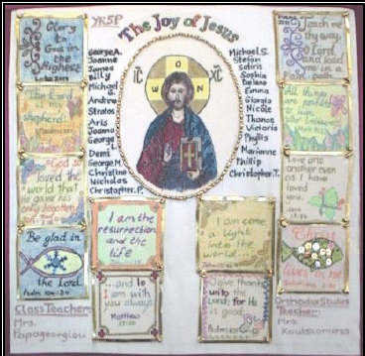

As Orthodox Christians we believe in one God --- The Father, the Son, and the Holy Spirit. That is, The Holy Trinity. The second person of the Holy Trinity is Jesus Christ, who is depicted in the centre of our panel. As part of our Bible reading in Orthodox Studies, we found many verses that tell us about Jesus. Some of these verses were written on squares of calico fabric and decorated with a border. These were then placed around the Icon of Jesus. As we read these verses we focus our attention on Jesus and we truly feel joy in our heart because in Jesus we see God, who loves us and has revealed a way for our salvation. Jesus has come to show us the way to God and to give us eternal life. Each verse has a special heartfelt meaning. Let us “rejoice in the Lord !”.
Sing to the Lord, all the world! Worship the Lord with joy; Come before Him with happy songs! Know that the Lord is God.
He made us, and we belong to Him; We are His people, we are His flock. [Psalm 100: 1 - 3]

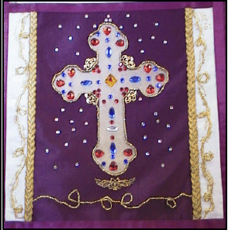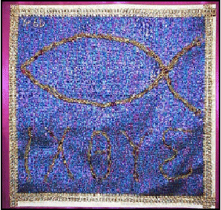

In the Orthodox Church we see, feel, hear, touch and do things, which constantly remind us of Jesus, Panagia and our Saints….
When we wear our Cross, venerate the Holy Cross and remember the events leading to Jesus’ crucifixion, we embrace the fact that Jesus so loved the world unconditionally that He sacrificed Himself so that we could live eternally with our Creator. The students in Mrs Inglis’ class were all given the task of threading gold glass beads onto metallic thread. The beads represent each individual united in faith and love. The separate completed threads were then tied together to symbolise that we are one body and Jesus is the Head. The jewelled Cross which was placed on burgundy fabric was carefully bordered by the beaded strands, showing us that we are truly protected and nurtured by Jesus and the Precious Life Giving Cross. The students’ names were written around the remaining beaded strands which were hand sewn in a ‘vine’ design on either side and underneath the Cross, thus depicting that Jesus is the true ‘vine’ of life and our names will be with Him forever…. Miss Douros’ class also participated in beaded work for their quilt panel, but theirs was a task of threading gold and red, round and rectangular glass beads onto gold wire. Each student designed his or her own pattern. Some threaded gold, others red and others a combination. The effect was spectacular and each
piece was then joined together and slowly twisted in layers to form the shape of a fish. The remaining strands were shaped into the letters ΙΧΘΥΣ. This word which literally means ‘fish’ in Ancient Greek, was used by the Early Christians as a means of identification and protection against persecutors. Interestingly the letters are an acronym that translates as “Jesus Christ, Son of God, Saviour’ (Éçóïýò ×ñçóôüò Èåïý Õéüò ÓùôÞñ). The Apostles were fishers of men. Jesus blessed the fish and bread to feed the multitudes. The empty nets were empty no longer when Jesus blessed them…. And of course we have all, as Orthodox Christians, been caught in the net of Jesus’ love. (Our apologies, unfortunately, the photographic image of this last panel could
not easily or successfully be reproduced in printed form. People will just have to make the effort to see the real thing!!)

